Pre-lab 1
Installing Packet Tracer and Wireshark
No mark for this lab
Instructions:
In Pre-lab, you will install two software Packet Trace (PT) and Wireshark into your computer. This part should be done before you get to class.
Procedures:
Download and install Packet Tracer, 8.2.2, or the latest on your PC.
What is Packet Tracer? It is a network simulator.

What are the system requirements for the Cisco Packet Tracer?
To successfully install and run Cisco Packet Tracer 8.2.2, the following system requirements must be met:
Cisco Packet Tracer 8.2 (64-bit):
- Microsoft Windows 8.1, 10, 11 (64bit), Ubuntu 20.04, 22.04 LTS (64bit) or macOS 10.14
- amd64(x86-64) CPU
- 4GB of free RAM
- 1.4 GB of free disk space
Download Packet Tracer

1-Click on the bottom link and download the latest PT onto your computer.
https://www.computernetworkingnotes.com/ccna-study-guide/download-packet-tracer-for-windows-and-linux.html

The file will be downloaded to the Download folder by default.
Note: don’t move it from the Download folder

Size: 227 MB
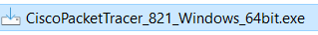
Version: 8.2.2 or the latest one.

PT installation procedure

Double-click on the Cisco packet Tracer file in the download folder and
Follow the default settings to install PT. Don’t change any settings.
You're done.

Wireshark installation:

Wireshark: https://www.wireshark.org/
What is Wireshark: it is a network software analyzer or sniffer.
1-Click the link above to download the Wireshark file: Windows 64-bit or macOS version.
2-Double-click on the Wireshark 4.2. file in the Download folder and click Next
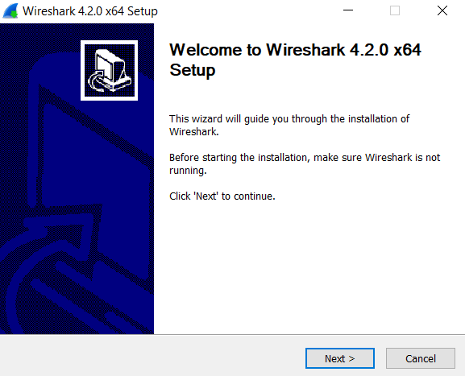

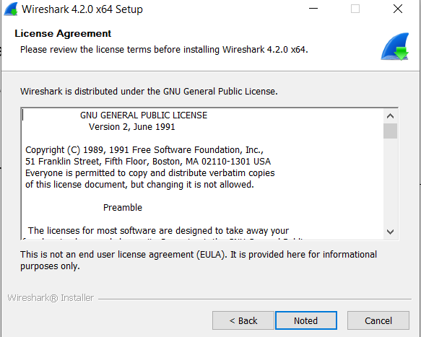

3-Accept the license agreement.

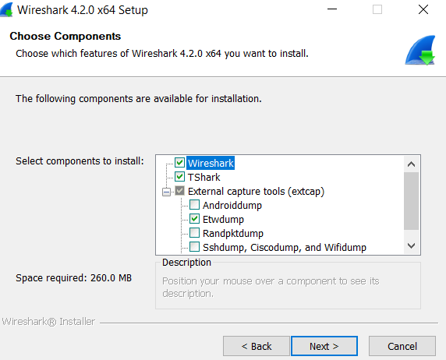

4-Choose components, (default) and click Next.

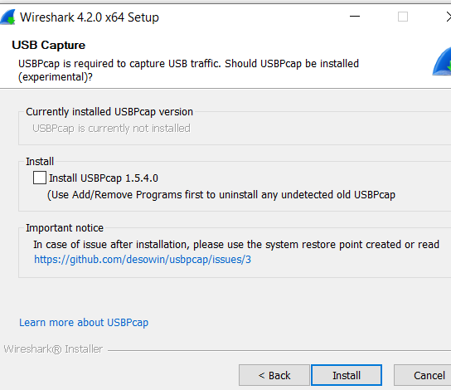
5-Additional Task, Click Next

6-USB Capture, click install
The installation takes a few minutes.
7-Click finish. Reboot your computer.
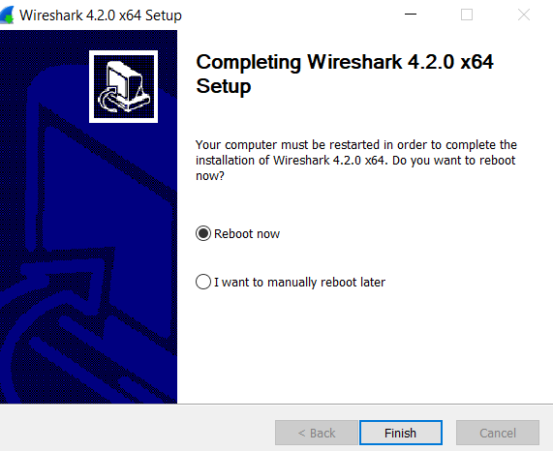
You are done.

Packet Tracer Training
Watch this video to learn about PK. (9 minutes)
https://link.brightcove.com/services/player/bcpid2649990253001?bckey=AQ~~,AAACaPvlvkE~,zCw2Hw90_KSOCz6LjW5G7qKEj3mIN-3H&bctid=4401112045001&secureConnections=true&secureHTMLConnections=true&autoStart=false

